**DAILY ONLINE ACTIVITIES SUMMARY**

|  |  |  |  |  |  |  |  |  |
| --- | --- | --- | --- | --- | --- | --- | --- | --- |
| **Date:** | **13-06-2020** | | | | | **Name:** | **Sinchana** | |
| **Sem & Sec** | **6 B** | | | | | **USN:** | **4AL17CS117** | |
| **Online Test Summary** | | | | | | | | |
| **Subject** | | **PAP** | | | | | | |
| **Max. Marks** | | **30** | | **Score** | | | **29** | |
| **Certification Course Summary** | | | | | | | | |
| **Course** | **Java programming** | | | | | | | |
| **Certificate Provider** | | | **E-box** | | **Duration** | | | **2 hours** |
| **Coding Challenges** | | | | | | | | |
| **Problem Statement: 1.** **electricity bill 2.** **non repeated character 3.pattern 4.** **sparse matrix** | | | | | | | | |
| **Status: Success** | | | | | | | | |
| **Uploaded the report in Github** | | | | | **Yes** | | | |
| **If yes Repository name** | | | | | **coding** | | | |
| **Uploaded the report in slack** | | | | | **Yes** | | | |

Online Test Details: (Attach the snapshot and briefly write the report for the same)

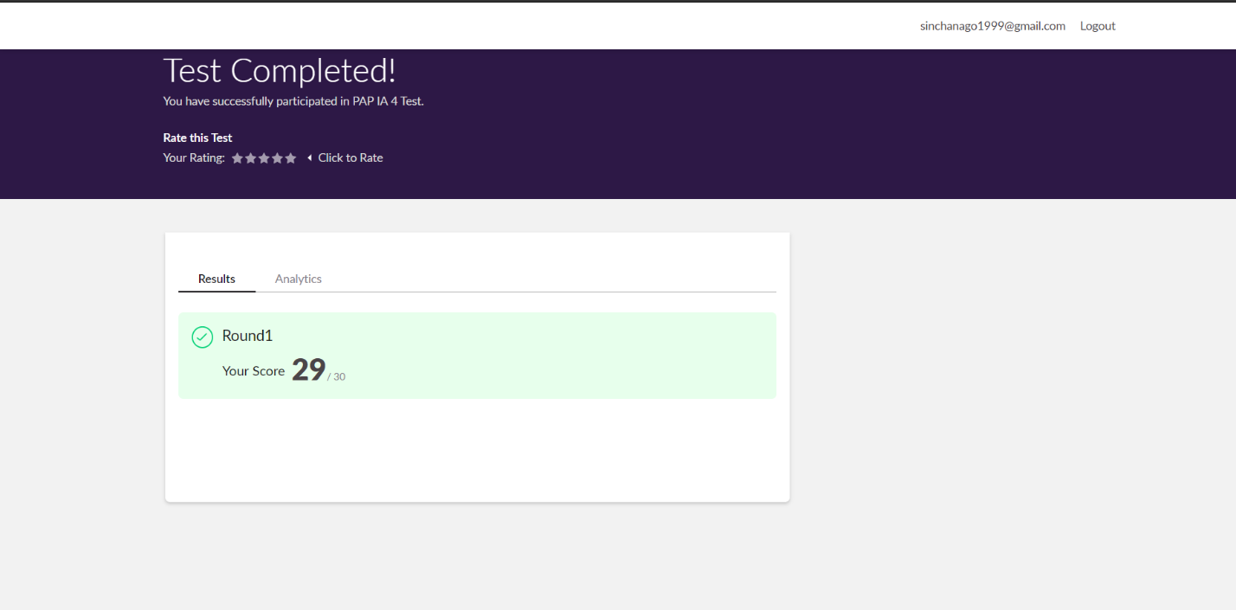

The test was held between 10:30 am to 11:00 am. It consisted of only 1 round and the total marks assigned was 30.The above snapshot is the output of my test.

Certification Course Details: (Attach the snapshot and briefly write the report for the same)

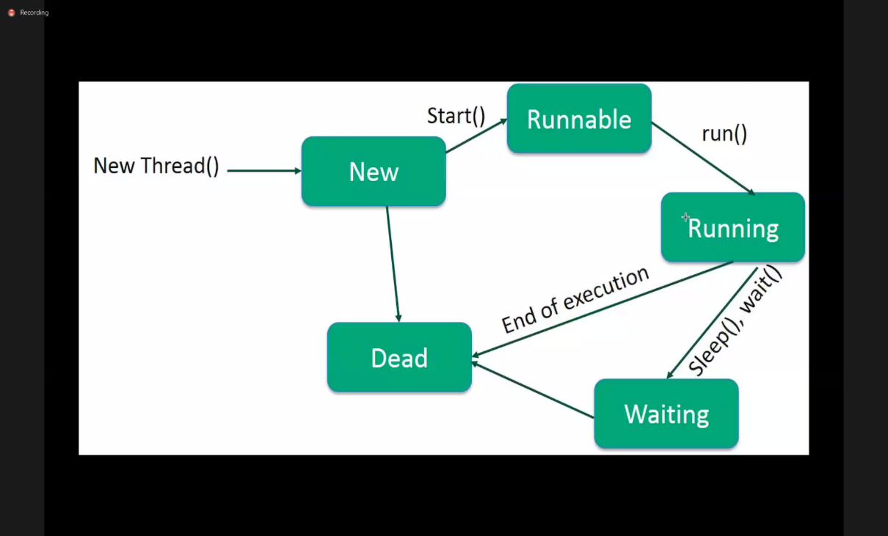

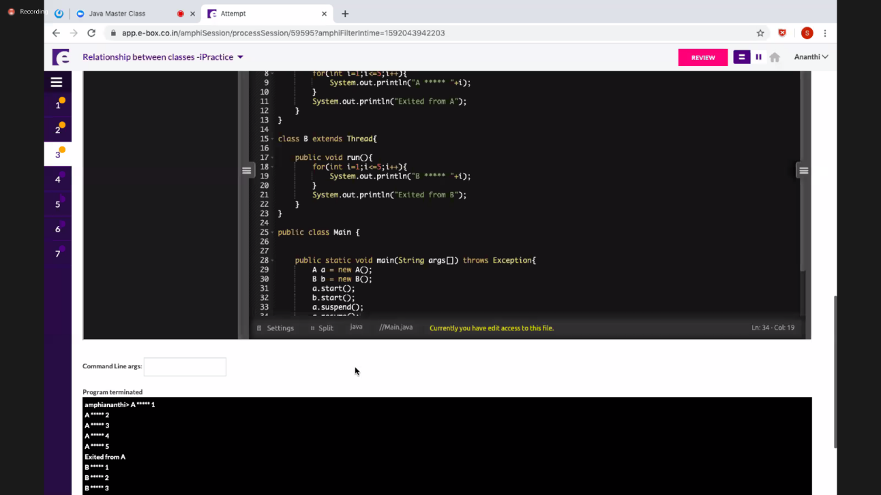

Today I have learnt about multithreading which defined as the ability of a processor to execute multiple threads concurrently. And multitasking where the operating system decides when to switch tasks external to Python. Learnt some of the methods like resume(), suspend().

Coding Challenges Details: (Attach the snapshot and briefly write the report for the same)

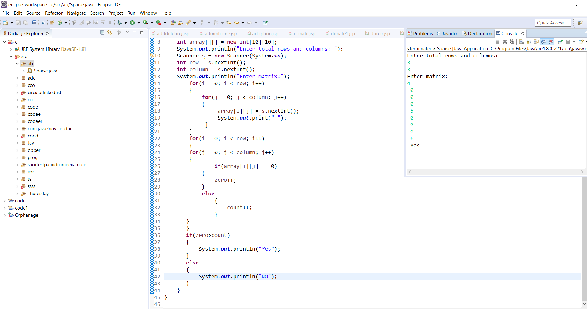

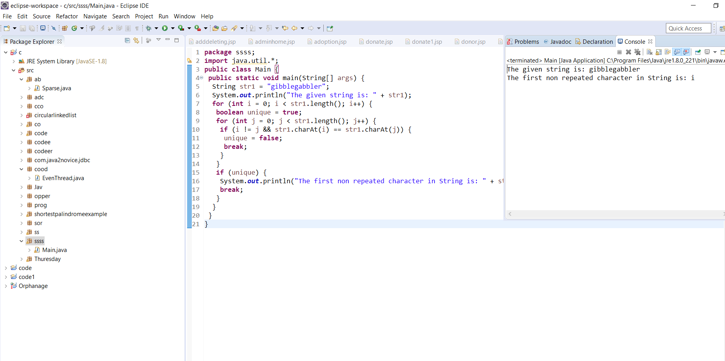

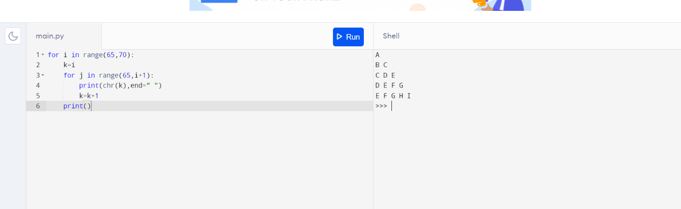

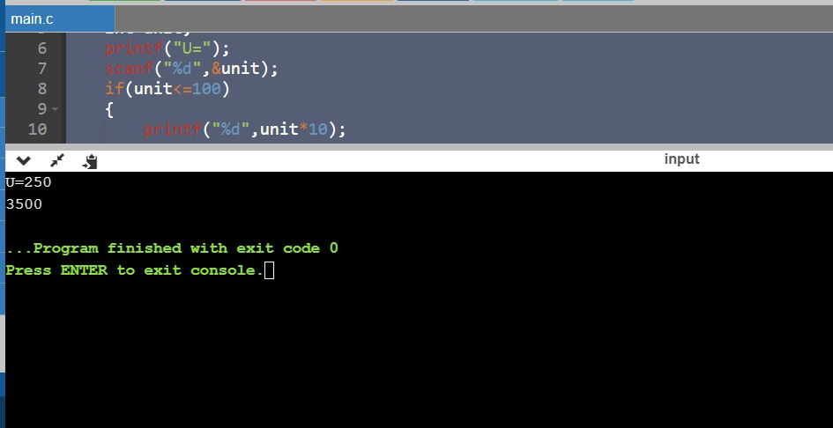

Link in GitHub : <https://github.com/sinchana514/coding>

<https://github.com/sinchana514/coding/tree/master/13th%20june>